─ A token made to connect restaurant and customer



BLACK DIA COIN

**◇ About**

BLACK DIA COIN (BDA) is a Waves token created on May 9, 2018, to connect restaurants and customers.

Currently it is a Waves token, but we plan to change it to a new coin in anticipation of the convenience and development of Ethereum ERC 223 standard.

For BDA, our goal is not just listing, but listing on multiple exchanges.

In addition, we would like to make BDA payable at multiple stores and have a plan to open our own restaurant where BDA is used as a method of settlement.

It is often said that many restaurants close their doors in the 3rd year of starting.

Although it is a tough industry, BDA exists to support such industry. We will act as a savior of the food industry in Japan as much as possible.

**◇ Importance of existence**

Restaurants are countlessly present and indispensable in our lives, for example, familiar bars, a restaurant on the first visit, eating places to go with important people, ramen shops, etc.

We think payment in such a case should be done as smooth as possible. So if you have a smartphone with our service you will be able to finish payment smoothly. And easier to buy a person sitting next to you a drink. This can be easily done without waiting for the store's settlement. BDA stays a step ahead of the current electronic money, it enables virtual currency payment.

**◇ Benefits of using crypto currency at stores**

BDA provides a system usable at stores that makes it realize much easier than introducing a norm payment system.

It will bring certain advantages for both stores and customers.

**１．Benefits of the store side**

BDA allows you to easily incorporate the system of settlement into stores with use of web. Therefore, the burden on the store side is also low, and it is possible to use the settlement system at low cost.

In addition, when using electronic money, the store has to pay fee to a certain extent, however you will be able to reduce it more with crypto currency.

**２．Benefit of the customer side**

We provide a system that allows customers to pay easily with only operation of smartphone.

By using our system, they can use discount and easily participate in the event.

And we can purchase BDA anywhere, not necessary to deposit at ATM beforehand.

**３．Benefits for both stores and customers**

By using block chain technology, anyone can confirm from use history that it is certainly remitted. Of course, as being encrypted and the security level is high, you can use it with confidence.

**◇ Things which could be done by using crypto currency**

We can imagine that the crypto currency will become more familiar to our lives in the near future. There have been several stores where payment is available by crypto currency.

Unlike electronic money, the market of crypto currency is always open.

Therefore, once you purchased it but did not use it at a restaurant, you can turn it into money.

This is one of the different viewpoints comparing with e-money so far. (Except any specific cases).

In addition, trading crypto currency is available for 24 hours 365 days.

And you can trade BDA at your own convenient time.

**◇ What you can do with BDA**

**１．Drinks (are) On Me function = DOM function**

With the BDA system, you can easily buy a drink for your neighbor.

In the bar, there are several times that you become friends with others you met in the bar. In that case, it would be cool if you could buy a drink for someone smoothly.

BDA will meet such demands.

1. Easy to buy a drink for someone with intuitive operation.



1. BDA for a glass of beer is remitted



1. Usage history is saved and we can see this in an easy-to-understand format.



Drinks (are) On Me function = with use of the DOM function provided by BDA, following things could be done;

As shown in the figure, using BDA, you can check "treat history". Even if you get drunk and do not remember last night, it will help to confirm how much you treat.

The given BDA is saved in your wallet. It will sound nice if you return a favor to the person or treat to another person.



With the chain of treating, there will be a circulation cycle of BDA. This ensures fluidity which is important as crypto currency.

In addition, at a drinking party where a lot of people participate, it would be natural that people want to split the bill. DOM function will help to do so easily.

**２．Store point function**

In BDA, we will offer a special service that you can get more benefit as you use it.

We will provide a system which enables to accumulate points when paying by BDA.

By providing this system, stores can increase the number of repeaters, customers can drink alcohol free of charge or convert it to another currency.

At convenience stores, you may be tired of being asked to submit a point card every time.

However, by making payment in a normal way, this function makes it possible to accumulate points on its own.

"Would you like point cards?" "No, thank you"

These unnecessary conversations are no more necessary.

**３．Discount function**

Now, we have so many events.

Halloween and Christmas, Valentine's Day, Summer Festival, Happy Hour and so on.

At such special occasions, the store would like to make a discount event.

The BDA system enables you to provide discount service easily to your customers. Such events would make it more excited. Discount given for customers wearing Yukata or Cosplay may also be part of the hot events.

**４．Providing a dedicated wallet**

At BDA, we plan to develop a dedicated wallet which can be used with either Android or iPhone. The function of Wallet is initially simple, but we will upgrade gradually.

**（１）Initial Release Support**

The shop side will issue a **QR code** with the settlement amount and the destination address together. By loading it you can send BDA.

BDA wallet also provides high level security.

Even if you get drowsy and fall asleep, it will never be stolen.

**（２）Version upgrade support**

We aim to develop a wallet with the following functions.

・2-step verification setting

・Find out people nearby via location information, then we can buy a drink for them or chat with. (DOM function)

・Like other electronic money, settlement is completed by simply passing over.

・Possible to store different crypto currencies other than BDA.

It can be said that it will be a wallet with a complete security system and a tool for information linkage.

**５．Expanding stores where BDA can be used**

We are currently selecting stores where BDA can be used.

First of all, we will try it out at existing stores.

Also, we will open up new restaurants in order to make crypto currency more familiar.

BDA will carry out these activities.

**◇ BDA Token Allocation**

**Development cost ... 30%**

Used as expenses for our own application development and R&D of settlement system.

**The amount to sell at the time of listing ... 45%**

We will sell 20% on initial listing.

For the rest, we will sell when listing on a new exchange as necessary.

**Marketing Expenses ... 15%**

Air Drop, official Twitter, Discord, and other promotional materials including distribution.

**Operation team ... 10%**

Use for collaborators and development team.

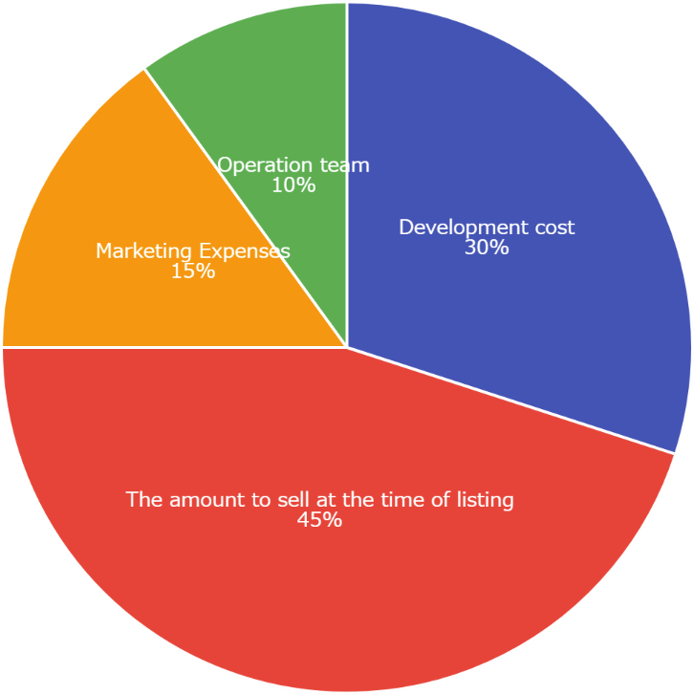

**SPEC**

Waves Token



Name　　　 ：BDA (BLACK DIA)

Total 　　：1 trillion

Asset ID ：ANdLVFpTmpxPsCwMZq7hHMfikSVz8LBZNykziPgnZ7sn

　　Decimals 　 ：1

Ethreum Token



(ERC223)

Name 　　　：BDA (BLACK DIA COIN)

Total 　 ：40 billion

Contract ：0xF6CaA4bebD8Fab8489bC4708344d9634315c4340

Decimals 　 ：8

<Notes>

Although it is now a Waves token, we are planning to change it with a token compliant with the ERC 223 as stated at the beginning.

At that time, we will replace the distributed Waves token with ERC 223 token.

We are also planning an exchange that will benefit people currently holding Air Drop.

**◇ Project organization**



**１．Management**

Representative：Furuta Kazuya

Others：６

**２．Incorporation of enterprise**

We will aim for incorporation after listing on the exchange on September 2018.

In order to show social credibility internally and externally,

I think that incorporation is necessary.

* About anti-social forces

The BDA project team has nothing to do with antisocial forces.

In addition, although the law is not yet maintained in the crypto currency, we have nothing to do with the bumping acts.

We have also confirmed that all project teams do not belong to such Discord.

Therefore, it is not necessary to worry about above when having partnership with us as payment settlement.

**◇ Roadmap**



─ We will move forward to be a savior of restaurants across Japan

BLACK DIA COIN TEAM

